IP CABLING TRANSMISSION – Active Series
ITEM NO.: IP02P IP Extender with Power over Coax

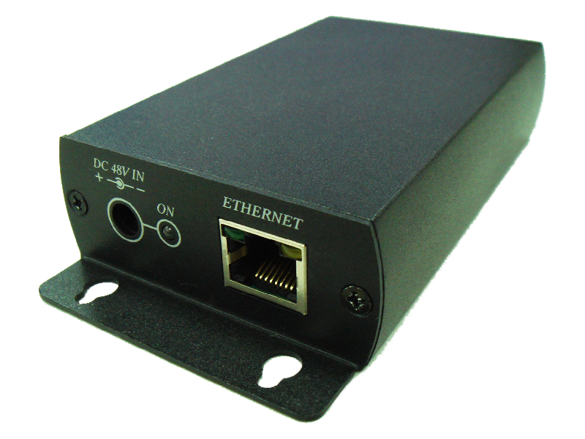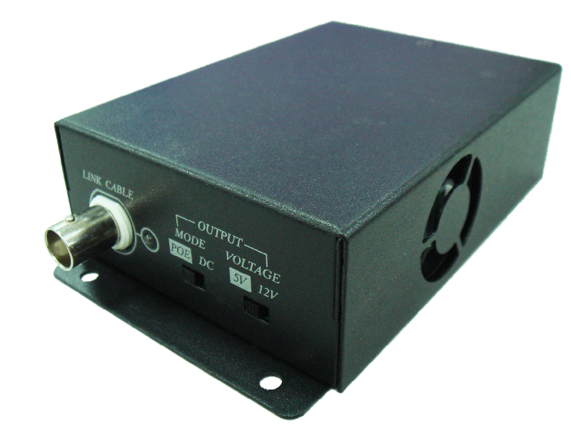

IP02P Extender is designed to send and extend IP or POE camera or any TCP/IP 10/100BaseT devices over existing coax cable. The distance could up to 180 meters by RG6U 75Ω Coaxial Cable. They are completely transparent to protocols, codes, and applications ensuring compatibility with any IP, POE camera and its management software. It is perfect solution for sending IP Video links and Power to remote camera installation that are beyond the 100 meters distance limit of Ethernet.

IP02P IP Extender with Power over Coax
- Send any extend IP / POE camera or any TCP/IP devices over existing coaxial cable.
- Maximum range up to 180 meters over RG6 75Ω Coaxial Cable, 125 meters over RG59 75Ω Coaxial Cable.
- Ability to send power over coax to IP/POE camera (DC5V, DC12).
- Support 10/100BASE-T transmission rate.
- Built in LED status indication.
- Package include external DC48V power adapter.

Installation View:

- Power input could use external DC 48V adapter or POE Injector to IP02PR unit.
- Before sending power to IP02PR, please make sure IP02PR with correct power switch to avoid any equipment damaged. (Power Switch: POE or DC. DC by 5V or 12V.)

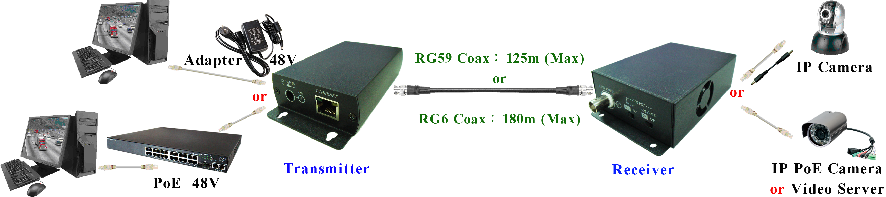

Panel view & Function:

IP02PT
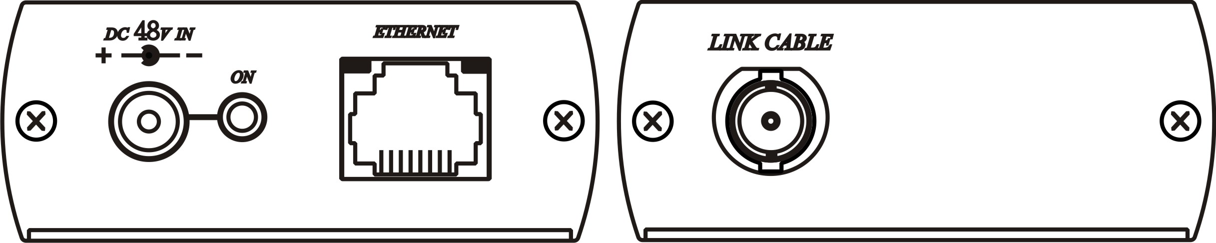

IP02PR
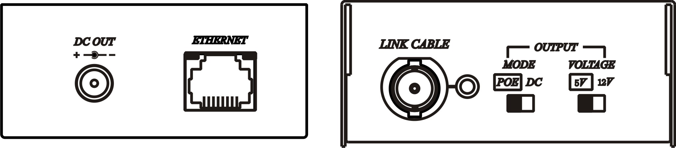

Remark：Power will be changed based on different input/output.

IP02PT power input with 2 option, one time only available one mode.
It can not use POE power input if power input selection by DC48V.

IP02PR power input with 2 option, one time only available one mode.
It can not use POE power output if power input selection by DC5V or DC12V.

Specifications:

ITEM | IP02PT | IP02PR
Data Input /Output | RJ45
Power, Data  Input /Output | RG6、RG59‧( 75Ω Coaxial Cable )
Distance | RG6 - 180M、RG59 - 125M ( MAX )
DC Input /DC Output | Input：Adapter DC48V (0.83A) | Output：DC 5V (1.3A)，DC 12V (0.8A)
DC Input /POE Output | Input：Adapter DC48V (0.83A) | Output：POE 48V (11W)
POE Input /DC Output | Input：POE 48V (12.95W) | Output：DC 5V (1.3A)，DC 12V (0.8A)
POE Input /POE Output | Input：POE 48V (12.95W) | Output：POE 48V (8.5W)
Switch | x | MODE POE / DC，VOLTAGE 5V / 12V
Dimension | 130 x 67 x 27 ( mm ) | 117 x 75 x 33 ( mm )
Weight (G) | 220 ( g ) | 320 ( g )

